Comsats University Islamabad
(Attock Campus)



NAME | WALID SHAHZEB
REG NO | SP24-BSE-032
SUBMITTED TO | Ms. AMBREEN GUL
EXAM | LAB TERMINAL
COURSE | IS
DATE | 15-DEC-2025

QUESTION 01:
Scenario: You are designing a secure email communication system that ensures
confidentiality, integrity, and authenticity of messages. The system uses Elliptic Curve
Cryptography (ECC) for encryption and the Digital Signature Algorithm (DSA) for signing
messages.
Tasks:
1. Key Generation:
2. Encryption/Decryption using ECC:
3. Digital Signature and Verification using DSA

CODE:
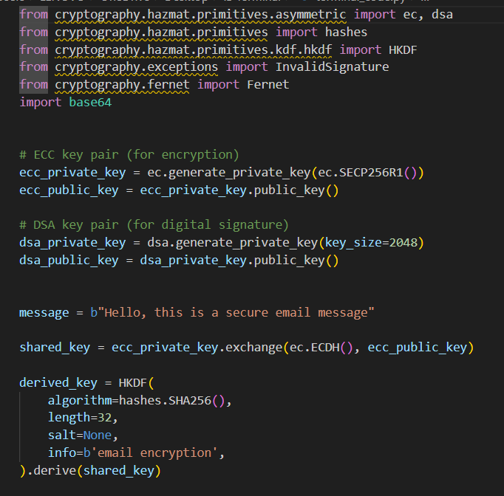
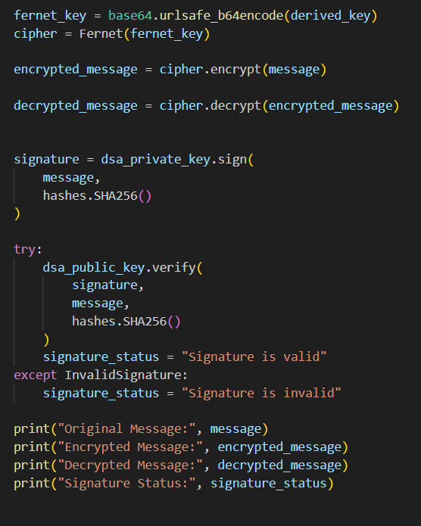
OUTPUT:
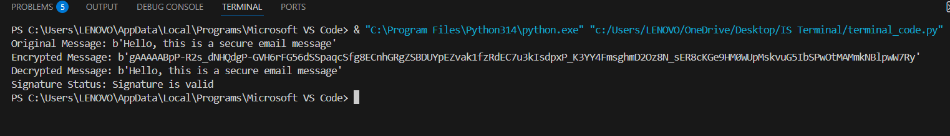

SIMPLE EXPLANATION:
- Key Generation: Each user generates a pair of keys—an ECC key pair for encryption (public/private) and a DSA key pair for signing.

- Encryption (ECC): The sender encrypts the email using the recipient’s ECC public key, ensuring only the recipient can decrypt it.

- Decryption (ECC): The recipient uses their ECC private key to decrypt the email and read the message.

- Digital Signature (DSA): The sender signs the message with their DSA private key to prove authenticity and integrity.

- Verification (DSA): The recipient uses the sender’s DSA public key to verify that the message is unaltered and really from the sender.

QUESTION 02:
You have developed a project during this course as your final submission. Using that same
project:
1. Justify your security method: Why is it suitable or better than other possible methods for
your type of project?
2. Identify one possible vulnerability or weakness in your current system. How could an
attacker misuse it?
3. Suggest one realistic improvement to enhance the security of your project. Briefly
explain how it would work.

ANSWER:
PROJECT: SECURE ENCRYPTION USING SALSA20 CIPHER ALGORITHM:

Salsa20 Cipher is the selected security method.
We have chosen to employ the Salsa20 cipher for this project for a number of good reasons:
Speed in Software-Only Environments:
When it comes to software-based encryption, Salsa20 truly excels. It functions incredibly well on systems without specialized encryption hardware. This is particularly crucial for gadgets like Internet of Things sensors, where processing speed and efficiency are crucial.
Simplicity and Safety:
Salsa20's simplicity is one of its best qualities. Salsa20 keeps things straightforward in contrast to some other encryption techniques, such as AES, which have complicated configurations (like selecting various modes of operation). A 32-byte key and an 8-byte nonce are all that are needed. Because of its simplicity, there is less possibility of implementation errors, making it safer all around.
Salsa20's performance is consistent.

Consistent Performance:
The hardware has no effect on Salsa20's performance. You can anticipate dependable encryption speed regardless of whether it is powered by an older or more recent CPU. This consistency is crucial for applications that need to run smoothly, no matter the hardware.
Resistance to Side-Channel Attacks:
Salsa20 is less vulnerable to some attacks that take advantage of timing and data access patterns because of its design, which includes operations like addition and XOR. An additional degree of security is thus added.

2. Identified Vulnerability:

Potential Drawback: Reusing Nonce
The potential for nonce reuse is one of our system's main vulnerabilities. An attacker could take advantage of this if they discover that the same nonce has been used repeatedly with the same key.
How It Could Be Abused by an Attacker:
They could XOR the resulting ciphertexts together, possibly exposing the original plaintext, if they observe repeated nonce use. When sensitive data is transferred without careful nonce management, this scenario is especially dangerous and could result in major security breaches.

3. Suggested Improvement

Enhancement: Putting in Place a Nonce Management System

We could implement a specialized nonce management system to prevent reuse and enhance our Salsa20 implementation. This is how it would work:

Unique Nonce Generation:
We could make sure that every encryption operation uses a different nonce. This might entail mixing a random value with a timestamp or counter. We reduce the possibility of reusing nonces in this way.

Nonce Storage and Tracking:
We would record each generated nonce along with the key that corresponds to it. We could effectively monitor nonce distribution and avoid double usage with the help of this record.

Validation Prior to Encryption:
The system would verify that a nonce hasn't already been used with the same key by looking through the stored nonces before encrypting any data.

